PROJECT REPORT
ON
“AI WIREFRAME TO CODE GENERATOR”
IS SUBMITTED TO
DR. BABSAHEB AMBEDKER TECHNOLOGICAL UNIVERSITY
IN THE PRACTICAL FULFILLMENT OF THE DEGREE OF
BACHELOR OF TECHNOLOGY IN
COMPUTER SCIENCE & ENGINEERING
BY
MR. IBRAHIM POPATIYA(43)
MR. SHAIKH UMAN SADIQUEALI (41)
GUIDE
MR. B.A. KHANSOLE


DEPARTMENT OF COMPUTER SCIENCE & ENGINEERING
MATOSHRI PRATHISHTHAN’S SCHOOL OF ENGNEERING, NANDED
2026-2027

CERTIFICATE

This is to certificate that the project entitled “AI WIREFRAME TO CODE GENERATOR” is being submitted by MR. IBRAHIM POPATIYA, MR. SHAIKH UMAN to “Dr Babasaheb Ambedkar technological University , Lonere Maharashtra ” as a partial fulfilment of award in Computer Engineering, is record of bonafied work carried out by them under my supervision and guidance the matter contain in this project work has not been submitted to any other institute for award of any degree

MR.B.A KHANSOLE MR.B.A KHANSOLE
(project guide) (Head of department)

DR.L.M Waghmare sir
(principal sir)

MATOSHRI PRATHISHTHAN’S

SCHOOL OF ENGNEERING
DEPARTMENT OF COMPUTER SCIENCE & ENGINEERING


Certificate

This is to certify that the Project

“AI WIREFRAME TO CODE GENERATOR”
Has been successfully completed in session 2025-2026 by
MR IBRAHIM POPATIYA
MR. SHAIKH UMAN
In recognition to the partial Fulfillment for
The degree of bachelor of technology (Computer science & Engineering),
Dr. Babasaheb Ambedkar Technological University , Lonere.

Mr.B.A Khansole Mr. B.A Khansole
GUIDE HOD

DECLARATION

We, MR IBRAHIM, SHAIKH UMAN hereby declare that we have completed the project.
We work towards the Bachelor of Technology Degree of Dr. Babasaheb
Ambedkar Technological University in computer Science & Engineering
Discipline on the topic entitled “AI WIREFRAME TO CODE GENERATOR ” Supervision of “B.A KHANSOLE SIR ” Matoshri Pratishthan’s School of Engineering , Nanded.
The report embodies the original work done by me in partial fulfilment of the requirement for the Degree of Bachelor of Technology of
Dr. Babasaheb Ambedkar Technological University in Computer Science &
Engineering

Place : Nanded MR IBRAHIM POPATIYA
MR SHAIKH UMAN

Date :

ACKNOWLEDGEMENT

We would like to place on record my deep sense of gratitude to Head of Department Mr. Khansole Sir and Guide Mr. Khansole Sir, Department of Computer Science & Engineering, Matoshri Pratishthan’s School of Engineering, Nanded, for his stimulating guidance, continuous encouragement and supervision throughout the work.
I also wish to extend my thanks to other staff members and friends for attending my seminars and for their insightful comments and constructive suggestions to improve the quality of this project work.
I am extremely thankful to Dr. L.M WAGHMARE Matoshri Pratishthan’s School of Engineering, Nanded, for providing me infrastructural facilities to work in, without which this work would not have been possible.

NAME: IBRAHIM POPATIYA (43)
MR. SHAIKH UMAN(41)

ABSTRACT

In the modern software development lifecycle, translating design concepts and wireframes into functional code is one of the most repetitive and time-consuming tasks. The AI Wireframe to Code Generator project aims to automate this bridge between design and development by using advanced Artificial Intelligence vision models to convert wireframe images directly into clean, responsive, and deployable React and Tailwind CSS frontend code.
The system allows users to upload any wireframe image (hand-drawn sketches or digital layouts), select an AI model, and enter a brief description. The uploaded image is stored in Supabase Storage, and the metadata is recorded in a PostgreSQL database using Drizzle ORM. The AI model (OpenAI gpt-4o) then analyzes the wireframe image and streams React component code styled with Tailwind CSS.
The generated code is cleanly parsed and instantly rendered inside an interactive live preview using the Sandpack React SDK. Furthermore, the application includes a chat-based modification interface, allowing developers to request layout adjustments, color theme updates, or interactivity additions by sending text prompts (and optionally uploading supplementary images) to perform real-time code modifications. This project showcases the power of AI in accelerating design-to-development handoffs, reducing manual coding time, and providing an iterative preview sandbox.

CONTENT

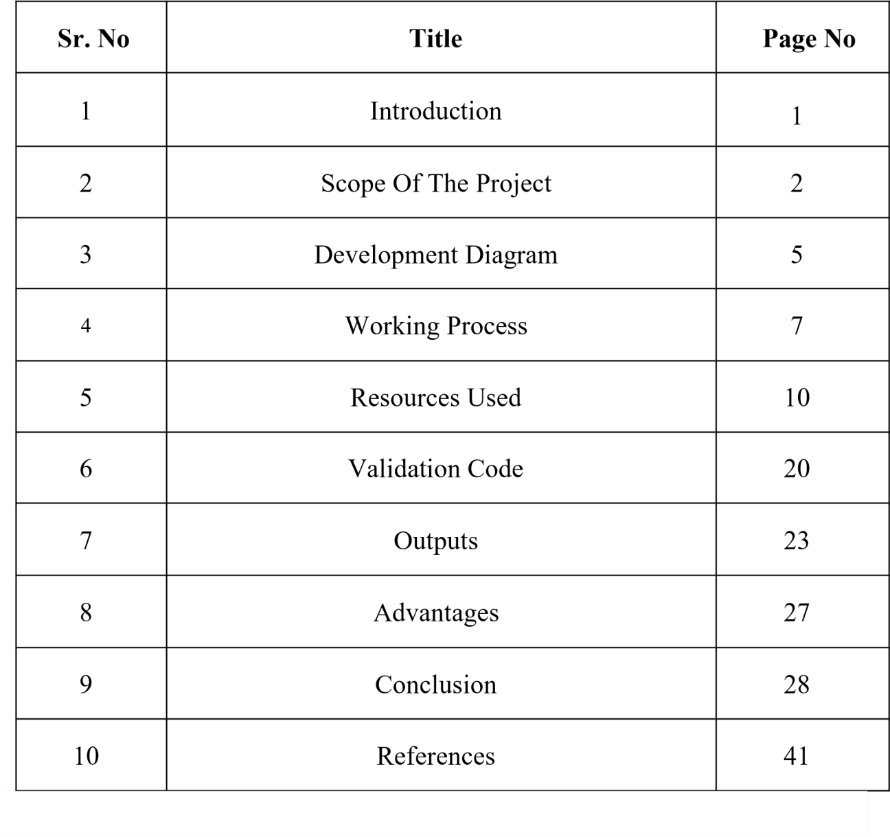

1. INTRODUCTION

In today's digital world, websites are essential for communication and business presence. However, traditional website development involves manually translating user interface (UI) designs and wireframe diagrams into coding languages like React, HTML, and CSS. This manual conversion can be slow and repetitive, and is prone to errors.
To address these issues, the AI Wireframe to Code Generator uses state-of-the-art vision models to automatically translate UI layouts from screenshots, drawings, or sketches into clean React code. With a built-in interactive code editor and live preview, users can instantly test and refine the UI.
The application is built on Next.js. Wireframe images are uploaded to Supabase Storage, and metadata is stored in a Postgres database managed by Drizzle ORM. The backend queries the OpenAI API, streaming code updates to the client in real-time.
The core objective of this project is to reduce frontend development cycles and provide a seamless, iterative sandbox where designs can be converted to code and modified on-the-fly using plain English text chat.

2. SCOPE OF THE PROJECT

The scope of the AI Wireframe to Code Generator focuses on automating design-to-code handoffs. The application is designed to receive UI sketch wireframes and translate them into responsive React functional components.
Core features in scope include secure image uploads to Supabase Storage, serverless backend handlers to interact with OpenAI vision APIs, real-time code streaming, client-side progressive code parsing, and an in-browser live preview sandbox leveraging the Sandpack SDK.
The generated code supports modern responsive layouts built with Tailwind CSS flexbox/grid, interactive React hooks (useState), and Lucide React vector icons. It supports subsequent edits by passing the previous code back to the AI model along with new chat instructions and optional image uploads.
The system targets UI/UX designers, developers, and product managers to accelerate visual prototyping. The scope is limited to single-page UI components and layouts.
Future scope enhancements could support full multi-page React application generation, direct GitHub synchronization, automatic deployment to hosting providers, and integration with live backend databases.

3. FRONTEND ARCHITECTURE
The client-side interface is developed using React and Next.js (App Router) for optimal performance and SEO. Tailwind CSS is utilized as the primary styling framework to allow rapid design prototyping. For live previews, the app integrates the @codesandbox/sandpack-react library. Sandpack provides a fully isolated, browser-based bundler and runtime environment that compiles the generated JSX code and renders it live on the screen without affecting the main application execution thread. Vector icons are supported via lucide-react.

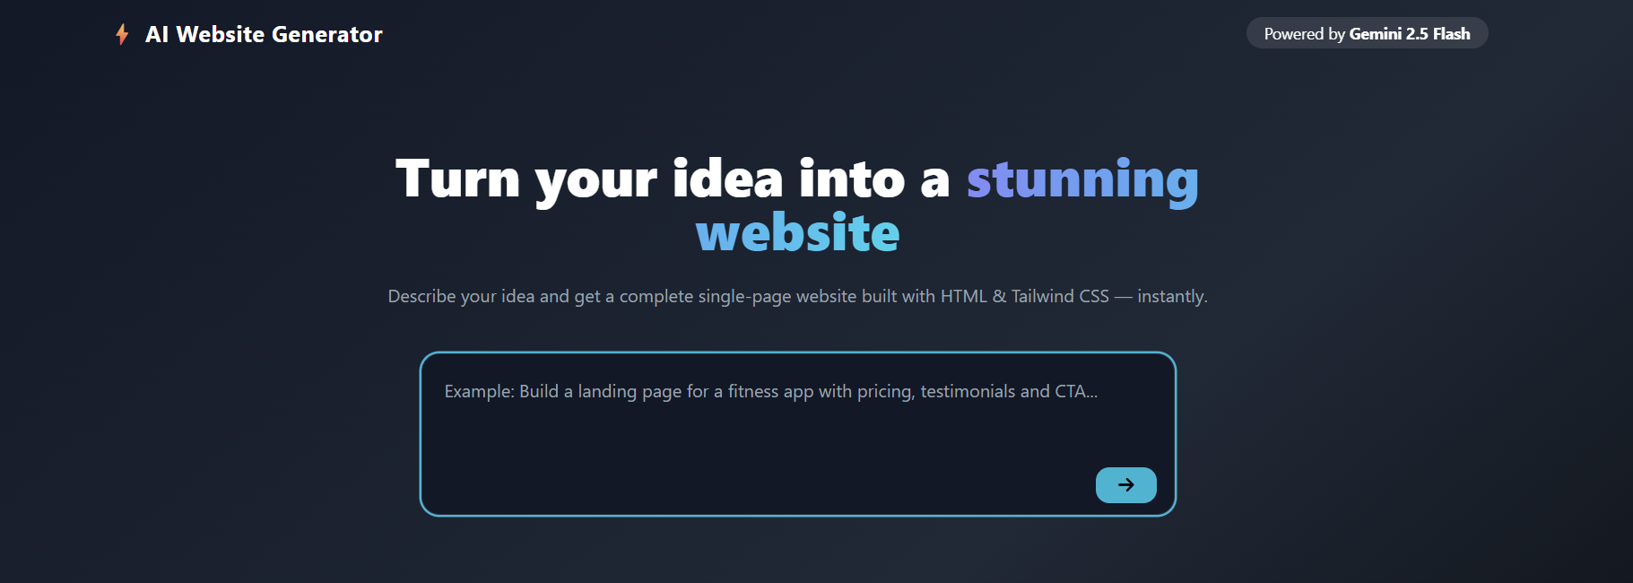

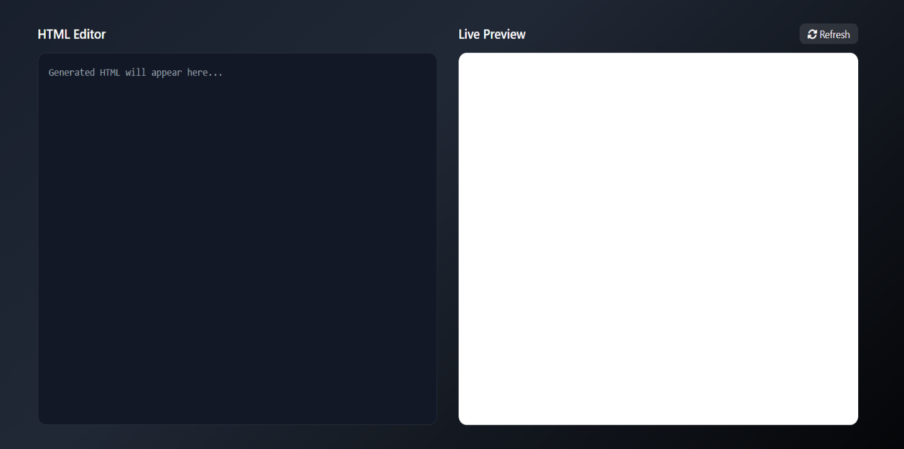
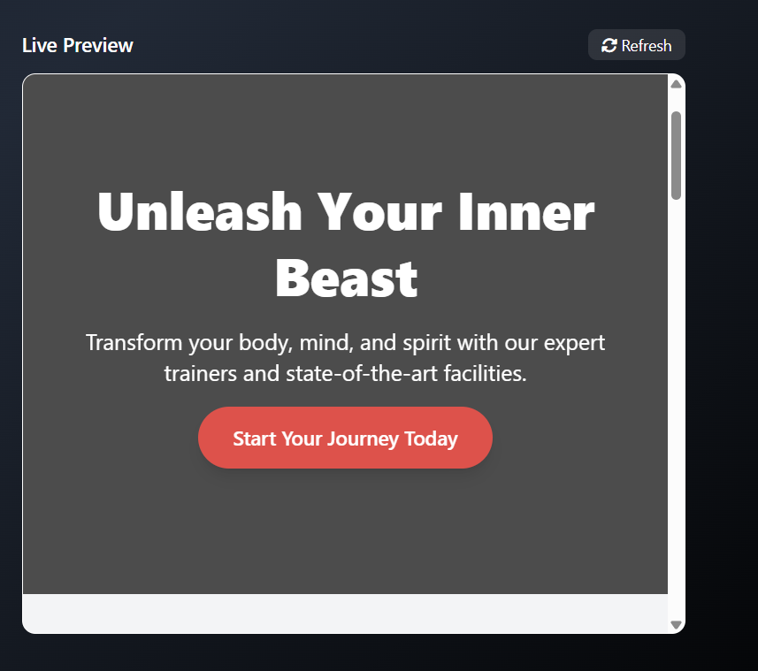

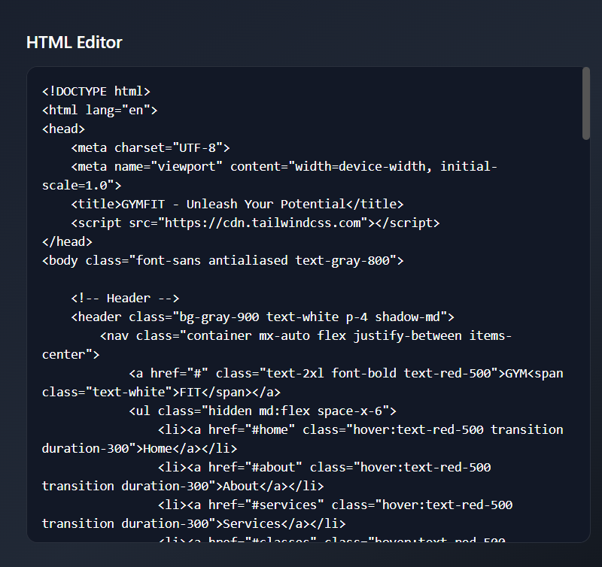

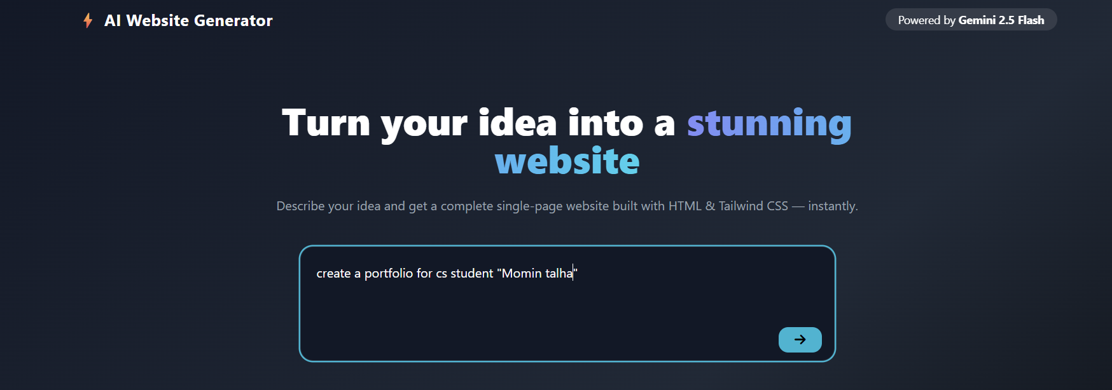
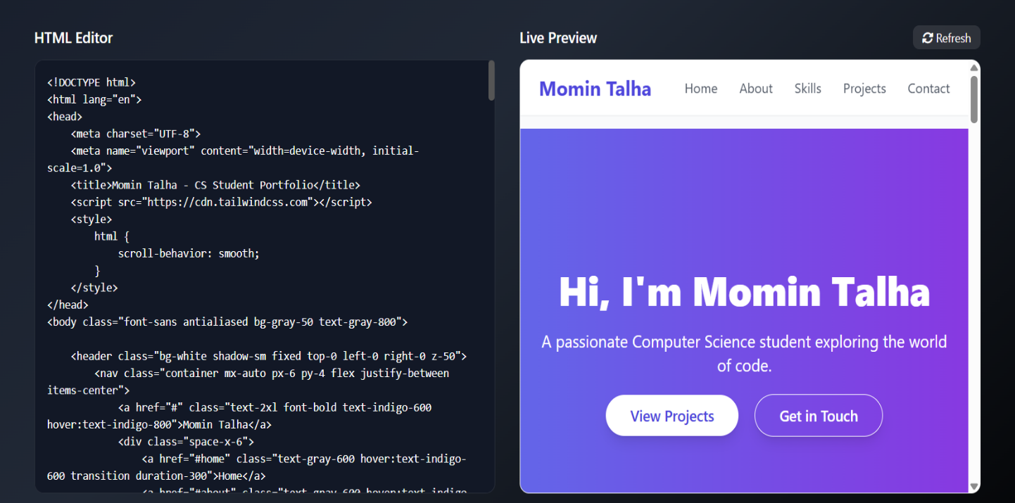

4. WORKING PROCESS

The working process of the AI Wireframe to Code Generator proceeds through the following pipeline:
1. Image Upload: The user uploads a wireframe image. The file is uploaded to Supabase Storage, and a unique public URL is generated.
2. Record Storage: Metadata (UID, model choice, description, image URL) is inserted into a PostgreSQL database using Drizzle ORM.
3. Vision AI Model Prompting: The client redirects to /view-code/[uid]. The backend route (/api/ai-model) calls OpenAI gpt-4o, passing the wireframe image URL and system instructions.
4. Progressive Code Rendering: The AI model's streamed code is cleaned in real-time, stripping out markdown formatting and injecting it into Sandpack for active visual rendering.
5. Chat-based Editing: The user can request updates via a text box. The app uploads any attached image, calls the AI API with the previous code and modification guidelines, and updates the editor dynamically.

The following technologies, tools, and libraries were utilized during the development:
- Next.js / React (v18+): Core frontend framework.
- Tailwind CSS: Utility-first styling framework.
- Supabase Storage: Object storage bucket to host uploaded wireframes.
- Neon PostgreSQL & Drizzle ORM: Database and query layer to store project metadata and code records.
- OpenAI API (gpt-4o): Vision LLM for code generation and contextual code updates.
- Sandpack React SDK: In-browser code bundler and rendering environment.
- Lucide Icons: Vector styling components.

Sr. no. | Name of Resources / material | Specification | Quantity | Remarks
1. | Laptop | I7-processor, RAM - 16GM | 1
2. | Operating System | Windows 11 | 1
3. | Processor | Intel i7 | 1
4. | Software | Visual Studio Code | 1

6. SOURCE CODE

--- [FILE: app/api/ai-model/route.tsx] ---
import OpenAI from 'openai';
import { NextRequest } from "next/server";
import { Constants } from '@/data/Constants';

const openai = new OpenAI({
apiKey: process.env.OPENAI_API_KEY,
});

export async function POST(req: NextRequest) {
try {
const { model, description, imageUrl, isEdit, existingCode, userInstructions } = await req.json();
const ModelObj = Constants.AiModelList.find(item => item.name == model);
let modelName = ModelObj?.modelName ?? "gpt-4o";

// Since we are using standard OpenAI client/key, we map OpenRouter models (containing '/') to gpt-4o
if (modelName.includes("/")) {
modelName = "gpt-4o";
}

console.log("Using OpenAI Model Name:", modelName, isEdit ? "(Edit Mode)" : "(Generation Mode)");

let messages: any[] = [];

if (isEdit) {
let promptText = `${Constants.EDIT_PROMPT}\n\nHere is the existing code:\n${existingCode}\n\nHere are the user's requested modifications:\n${userInstructions}`;

if (imageUrl) {
promptText += `\n\nAdditionally, the user has uploaded/attached a new image. If they asked to use, display, or replace an image, use this exact URL for the image src attribute: "${imageUrl}"`;
}

messages = [
{
role: "user",
content: [
{
type: "text",
text: promptText
}
]
}
];
if (imageUrl) {
messages[0].content.push({
type: "image_url",
image_url: {
url: imageUrl
}
});
}
} else {
messages = [
{
role: "user",
content: [
{
type: "text",
text: description
},
{
type: "image_url",
image_url: {
url: imageUrl
}
}
]
}
];
}

const response = await openai.chat.completions.create({
model: modelName,
stream: true,
messages: messages,
});

const stream = new ReadableStream({
async start(controller) {
const encoder = new TextEncoder();
for await (const chunk of response) {
const text = chunk.choices?.[0]?.delta?.content || "";
controller.enqueue(encoder.encode(text));
}
controller.close();
}
});

return new Response(stream, {
headers: {
"Content-Type": "text/plain; charset=utf-8",
},
});
} catch (error: any) {
console.error("AI Generation error:", error);
return new Response(JSON.stringify({ error: error.message }), {
status: 500,
headers: { "Content-Type": "application/json" },
});
}
}

// import OpenAI from 'openai';
// import { NextRequest } from "next/server";
// import { Constants } from '@/data/Constants';

// const openai = new OpenAI({
// baseURL: "https://openrouter.ai/api/v1",
// apiKey: process.env.OPENROUTER_AI_API_KEY,
// });

// export async function POST(req: NextRequest) {
// try {
// const { model, description, imageUrl } = await req.json();

// const ModelObj = Constants.AiModelList.find(item => item.name === model);
// const modelName = ModelObj?.modelName ?? "google/gemini-2.0-flash-exp:free";

// const response = await openai.chat.completions.create({
// model: modelName,
// stream: true,
// messages: [
// {
// role: "user",
// content: [
// { type: "text", text: description },
// { type: "image_url", image_url: { url: imageUrl } }
// ]
// }
// ],
// });

// const stream = new ReadableStream({
// async start(controller) {
// const encoder = new TextEncoder();
// for await (const chunk of response) {
// const text = chunk.choices?.[0]?.delta?.content || "";
// controller.enqueue(encoder.encode(text));
// }
// controller.close();
// }
// });

// return new Response(stream, {
// headers: {
// "Content-Type": "text/plain; charset=utf-8",
// },
// });

// } catch (error) {
// console.error("API /api/ai-model error:", error);
// return new Response(JSON.stringify({ error: 'Internal Server Error' }), {
// status: 500,
// });
// }
// }

// export async function POST(req: NextRequest) {
// try {
// const { model, description, imageUrl } = await req.json();

// const ModelObj = Constants.AiModelList.find(item => item.name === model);
// const modelName = ModelObj?.modelName;

// if (!modelName) {
// return new Response(JSON.stringify({ error: "Invalid model name" }), { status: 400 });
// }

// const response = await openai.chat.completions.create({
// model: modelName,
// stream: true,
// messages: [
// {
// role: "user",
// content: [
// { type: "text", text: description },
// { type: "image_url", image_url: { url: imageUrl } }
// ]
// }
// ],
// });

// const stream = new ReadableStream({
// async start(controller) {
// for await (const chunk of response) {
// const text = chunk.choices?.[0]?.delta?.content || "";
// controller.enqueue(new TextEncoder().encode(text));
// }
// controller.close();
// }
// });

// return new Response(stream, {
// headers: {
// "Content-Type": "text/plain; charset=utf-8",
// },
// });
// } catch (err: any) {

8.ADVANTAGES

1. Automated Website Creation

1. Automated UI Code Generation: Instantly translates design sketches and wireframes into clean React components, bypassing days of manual layout coding.

2. Save Prototyping Time: Reduces iteration speed, turning design handoffs into a matter of minutes.

3. Live Preview Integration: Sandpack provides a secure sandbox to compile code and preview layouts interactively directly in the browser.

4. Chat-based Modifications: Enables non-technical users to request revisions and visual adjustments via simple text chat.

5. Support for Supplemental Image Inputs: Users can attach asset images or alternative layout designs to guide the AI's changes.

6. High Design Fidelity: Automatically generates responsive layouts with correct alignments, spacing, and styling grids using Tailwind CSS.

7. State Integration out-of-the-box: Supports interactive states (like input fields and interactive buttons) using React hooks.

8. Secure Cloud Storage: Standardizes image storage with Supabase, generating shareable image reference links.

9. Structured Database Management: Uses Neon serverless Postgres and Drizzle ORM to maintain project UIDs, configurations, and historical code revisions.

10. Extensible Architecture: Designed with standard Next.js route handlers, making it simple to add more LLMs, templates, or integrations in the future.

The generated websites are responsive and compatible with different screen sizes such as mobile phones, tablets, and desktops.
📌 Example: The same website automatically adjusts its layout when opened on a mobile device.

6. AI-Based Layout and Content Optimization

Artificial Intelligence helps in organizing content and selecting suitable layouts based on website purpose.
📌 Example: For an e-commerce website, the AI prioritizes product sections and call-to-action buttons.

7. User-Friendly Interface

The system provides a simple and interactive interface that guides users through the website creation process.
📌 Example: Users just fill in forms and select options instead of writing code.

8. Cost-Effective Solution

The AI Website Generator reduces the cost of hiring professional web developers or designers.
📌 Example: Small businesses can create websites without paying high development fees.

9. Faster Deployment

Websites generated by the system can be easily downloaded or deployed, speeding up the launch process.
📌 Example: A startup can launch its website on the same day it is created.

10. Customization Flexibility

Users can modify content, colors, and layouts according to their needs even after the website is generated.
📌 Example: A user can regenerate the website with a different color theme for branding purposes.

11. Scalable and Extendable System

The project can be enhanced in the future by adding advanced features such as backend integration and SEO tools.
📌 Example: In future versions, database and login systems can be added.

12. Real-World Application and Learning

The project reflects real-world AI applications and helps students understand automated web development.
📌 Example: Students gain hands-on experience with AI-driven design and development workflows

9.CONCLUSION

The AI Wireframe to Code Generator project successfully demonstrates the capability of advanced vision LLMs to automate frontend coding from user interface designs. Translating UI layouts to code has traditionally been a manual, visual-to-syntax process. This application automates that workflow, producing high-fidelity React components.
By integrating the Sandpack compiler and a text-based modification chat panel, the system establishes a complete visual prototyping loop. Users can iterate on details, change theme styling, and add functionality on-the-fly.
The application provides high value for developer workflows, rapid design validation, and non-technical founders who want to prototype mockups. It cuts development time, bridges designer-developer communication, and ensures a streamlined visual experience.
Overall, the project is a scalable, modern Next.js implementation showing how vision LLMs and interactive sandboxes can be combined to automate frontend design translation.

10.REFERENCES

1. Next.js Documentation: https://nextjs.org/docs
2. React Documentation: https://react.dev
3. Tailwind CSS Utilities: https://tailwindcss.com/docs
4. OpenAI API & gpt-4o Model: https://platform.openai.com/docs
5. Supabase Storage API: https://supabase.com/docs/guides/storage
6. Drizzle ORM & Postgres: https://orm.drizzle.team/docs

